Cancellation test amendments

**Presentation**

* No overlapping stimuli on screen
* Each cancellation task should have an equal number of each kind of distractor (right and left gap mugs). The number of targets and distractors should always be proportional.
* I know you have made numbers of distractors and targets easy to change in the code. We should keep that flexibility (especially if we want to use this task as a training task for visual search problems or attention, eye movement training). However in our diagnostic mode the are our recommended specs:
  + 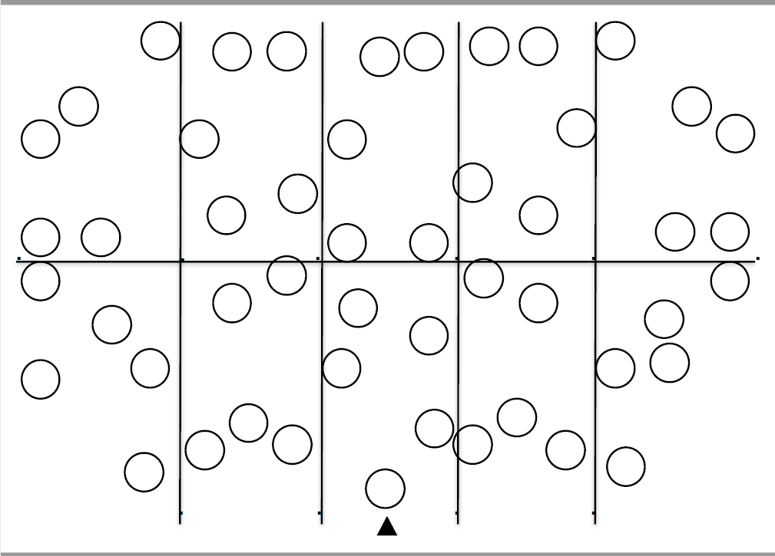Split matrix into a grid (e.g., two rows and five columns to ensure probability of cancellation are balanced). Grid not visible to patients.
  + Two-thirds of total stimuli should be distractors with a left or right gap. Each screen is split into 10 cells; each cell contains 5 targets, 5 left-gap distractors, 5 right-gap distractors. In total 50 targets, 100 distractors (50 left and 50 right-gapped hearts). In addition, targets and distractors should change in size. Three large mugs in each cell, one target, one left-gap, and one right-gap. We could have small and large versions of targets and distractors – small versions to be 75% the size of the large version (based on broken hearts) or 50% of the size (Apple cancellation task).
* Have different versions of the grids for each test so that stims are presented in different positions on the grid (version 1 – targets on bubbles as in figure above, version 2 distractors in bubbles). This allows us to re-do the same test but prevent learning of position.
* Large broken mugs (distractors) should have a gap of 4mm on handle Proportional gap for smaller version of distractors.
* Two practice trials already sent to Owen. If patients complete practice 1 correctly, they move onto full task. If first practice not completed correctly, have a second practice (see below for instructions).
* No mark option should be called ‘invisible cancellation condition’
* In the ‘invisible cancellation condition’ there should be a visible mark immediately after clicking on the mug (so users know the computer has registered their click), but this mark should disappear within 2s? – this will have to be formally tested to see what neglect patients can detect as marked
* At present tests take a long time to load even in our super-duper laptop (takes a couple of minutes to launch).
* For our records total limit time for each task will need to be formally tested in neurologically-intact individuals of different ages so that we can decide how long to give patients for each task depending on their age

**Response**

* Give written and auditory instructions:

“You will see a screen with lots of mugs on. Some mugs will be complete and some will have a gap on the handle. Please click all the complete mugs (those with no gaps). Try this practice, please click on all the complete mugs you see along this line”

“Well done. Now do the same on this screen, please click all the complete mugs” – if completed correctly

“Please try the practice again [and repeat main instructions]” - if incorrect on practice trial.

* At present hovering over a stimulus represents a click and we know that neglect patients may hover on target but actually not detect it. So this needs to be changed to a click as representing cancel rather than just hovering
* We recommend using mouse not leap due to logistical/positioning problems when used in people’s homes (long cables from laptop to where participant is sitting in front of TV) and cannot click using Leap.
* A larger mouse cursor or of better colour – especially if patients will be away from TV (not directly in front of a monitor).
* The mark that indicates cancel is good. But the rotating circle should have colours that facilitate viewing so that there is high contrast with background (black or maybe dark blue?)

**Measurements and Scoring**

* Any scoring or graph should appear after the test is completed (not on the screen while the task is being completed – how it is now is good).

Accuracy

* Overall accuracy (correctly detected targets) as % (potentially with numbers and graphs)
* % accuracy per quadrant: left, middle right (potentially with numbers and graphs)
* % distractors crossed overall and per quadrant per type of distractor (right or left gap)

Timing

* Total amount of time spent on task
* % time spent searching on left side of screen and % time spent on right side of screen as a function of total time
* Asymmetry time score. Subtract % time spent on right side by % time spent on the left. If positive then there is a rightward bias in search and if negative, there is a rightward bias in search. If it’s zero no bias.
* Search speed – calculated using the average distance between cancellations by the time between each cancellation. Calculate search speed over all targets on screen, and within left/right sides of grid.

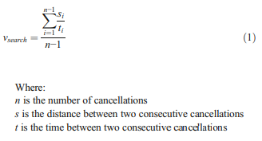

* Re-clicks and revisits: Record the re-click rate using total number of re-clicks/total number of targets clicked upon as a percentage for each patient per quadrant (e.g., 60% of total re-clicks during task occurred in the left side of screen).

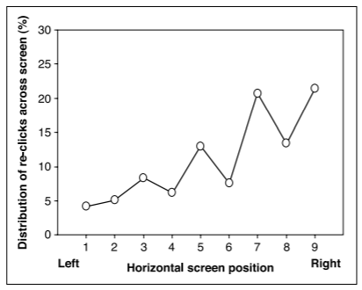

* Measure time between clicking and re-clicking on a target – more likely a patient will re-click when there is an increased delay between first click and the revisit.

Spatial bias scoring

* Sub-type scores:
  + Egocentric Neglect (e.g., neglect left side of screen) - subtract the total number of targets cancelled in left sections of the grid by total number of targets cancelled in right sections of grid (targets in centre of grid not included). If patient cancels more targets on right sections of grid, a negative value is given (rightward bias). If more cancelled in left of the grid, a positive score is given (leftward bias).

Positive value = right egocentric neglect (leftward attentional bias)

Negative value = left egocentric neglect (rightward attentional bias)

Example of left egocentric neglect:

Total targets cancelled in right side of grid = 10

Total targets cancelled in left side of grid = 2

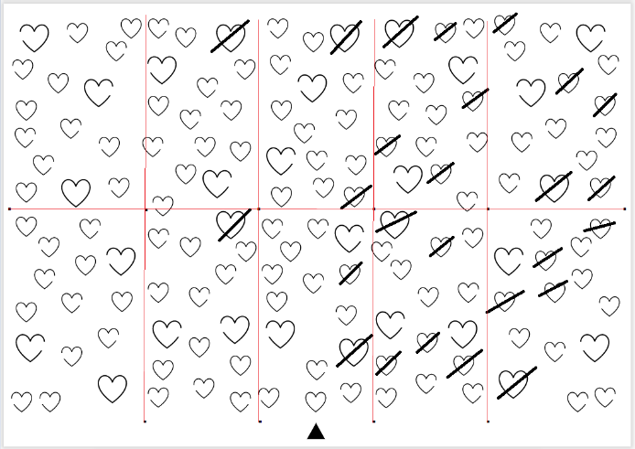2 – 10 = -8 🡪 left egocentric neglect (neglect of left side of space seen in example below).

* + Allocentric neglect (see gap as full stim when gap is towards neglected side regardless of position on screen) – subtracting total number of right-gap distractors by total number of left-gap distractors cancelled across grid. If patient cancels more mugs with right-gaps, a negative value is given (right allocentric neglect). If patient cancels more mugs with left side-gaps a positive score is given (left allocentric neglect).

Positive value = left allocentric neglect

Negative value = right allocentric neglect

Example of right allocentric neglect:

Total number of left-gap hearts cancelled = 25

Total number of right-gap hearts cancelled = 3

3 – 25 = -22 🡪 right allocentric neglect (sees right-gap hearts as complete – neglecting right side of stimulus).

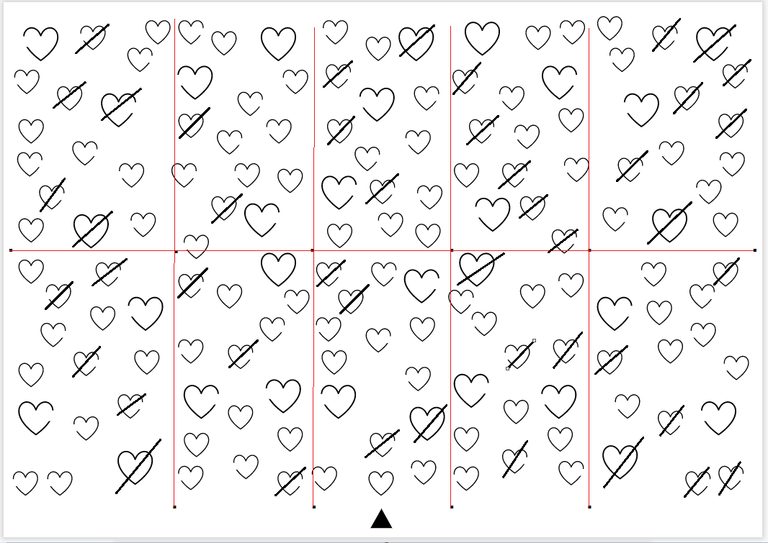

Search and cancellation patterns

* Search path map: In this map we should present the screen with locations of targets (as dots – see figure below) and plot the sequence of cancelled targets – attach a number (in ascending order) to each target cancelled (first target: 1, next target: 2, etc.). In addition we should also include as per below where they clicked (as it may not overlap with target) and join all cancelled targets in path. Present revisits clearly on search maps – perhaps with different colour indicating a revisit to an already detected target/distractor. Could do the same map but with hovering data (without clicking)

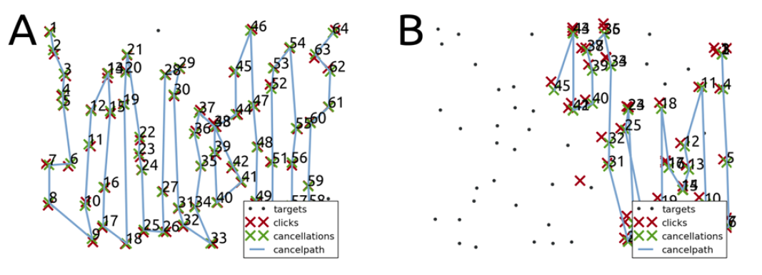

* Cancellation Path intersection rate - Number of times cancellation path crosses over itself (e.g., patient revisits a previously searched area to cancel a target). Few intersections would show an efficient search pattern (able to find targets in one area during first search, no need to revisit area). Total amount of intersections (crossovers of paths) is divided by total amount of markings (e.g., in figure B, number of intersections = 1. Total amount of markings = 4. 1 divided by 4 = 0.25.

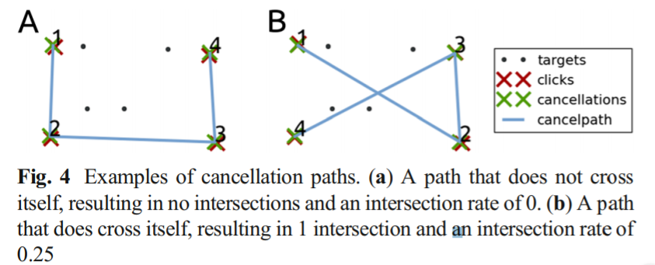

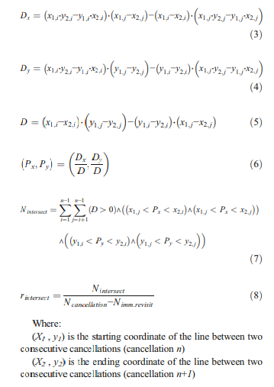

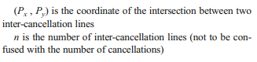

* Search Latency map – Latency is the time passed from the hit on the previous item. On map of data output, a circle appears around a target showing the amount of time it took the patient to detect the next target, from the last. A large circle around the detected target would indicate a longer amount of time passed before the patient found the next target. Whereas, a smaller circle around the detected target would show the patient found another target quickly. This visually presents whether patients are taking longer between targets in a particular quadrant (e.g., longer times between target detections in the more affected side).

See figure below to show this:

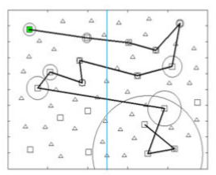

Longer delay finding next target

Short delay finding next target

* Quality of search (Q score) – shows speed and accuracy of search as a single measure. Calculated using equation below. High Q score = high number of targets detected and high cancellation speed. Calculated for overall quality of search over whole screen and within either the left/right side of screen (e.g., quality of search within left side of screen).

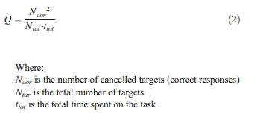

* Standardized inter-cancellation distance – the distance (in pixels) between two sequentially cancelled targets (e.g., distance between cancelled targets 1 and 2). Average distance between cancelled targets, divided by average distance between each target and nearest neighbouring target. An organized search pattern would have a low standardized inter-cancellation distance (cancelling targets, which are close to each other, instead of ‘jumping’ to targets all over the screen).

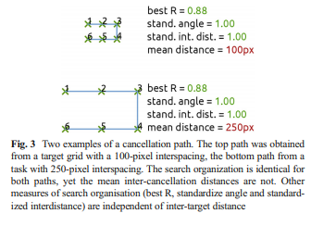

* Best R – assesses cancellation strategy. Calculated using rank number of cancellation and horizontal and vertical cancellation position. Example of most efficient search pattern/R (searching from left to right; image A), gives high R = 1:

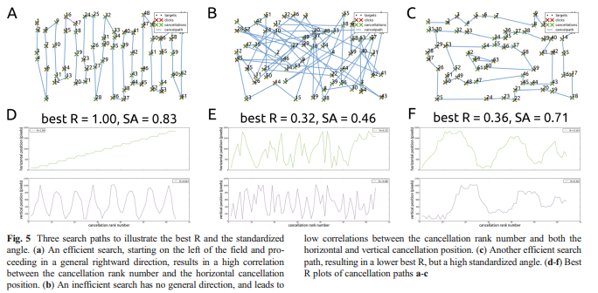

Heat maps

* Click maps - to show locations of clicks over grid. Should produce one heat for overall clicks (not necessarily on a target) and one for target detection rates. Heat maps are formed as a function of two-dimensional target position (bicubic interpolation between target locations). Red/yellows show higher levels of target detection. Whereas, cooler colours (e.g., blues) show areas where less targets were detected.

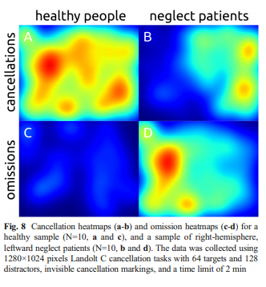

* Standardized angle – High standardised angle indicates an efficient search pattern, horizontal and vertical lines are more efficient search paths (going from target to target close by, not jumping around the screen). Angles between two cancelled targets which are either 0 or 90 degrees equals a standardized angle with approaches 1 (efficient search)

